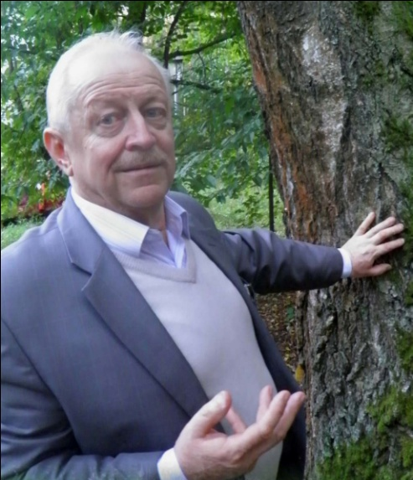

Vladimir M. YEFIMENKO
Associate professor
Candidate of Agricultural Sciences

Vladimir M. Yefimenko was born on the 31st of July, 1945 in Novozybkov (Bryansk Region, Russian Federation). He is an active forestry specialist and ecologist, the Candidate of Agricultural Sciences (1981), the Associate professor of Forest Management speciality (2009).
Mr. Yefimenko graduated from Bryansk Technological Institute in 1968 and received his post-graduate training at “Forest Institute of the National Academy of Sciences of Belarus”.
He also specializes in the sphere of forest resources studies, afforestation inspection and forest phytocenoses formation methods.
He is the author of more than 100 research papers and 4 patented innovations.

Publications:
- Growth intensity of oak component in mixed oak plantations // Izvestiya of Gomel State University. – 2011. - №4 (67). – PP. 124-128.
- The growth of coniferous-deciduous plantations // Izvestiya of Gomel State University. – 2008. - №5 (50). – Vol. 2. – PP. 109-113.
- The formation of pine-birch plantations // Minsk, MFM of the Republic of Belarus. – 2006. – 20 p.
- Height variability of spruce in mixed coniferous-deciduous plantations // BSTU (Forest Management). – №11. – 2003. – PP. 66-71

