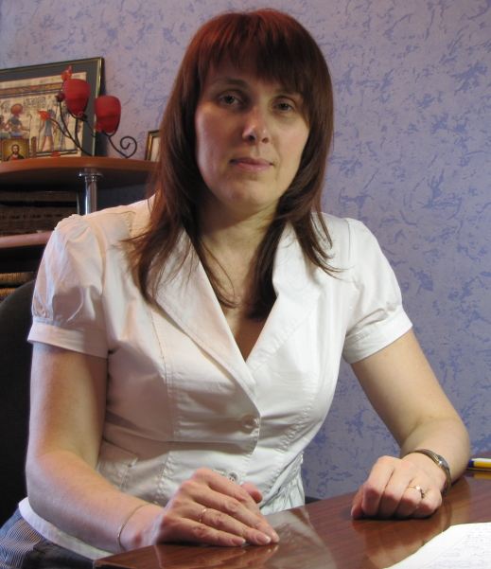

Tatyana V. Makarenko
Tatyana Makarenko was born on 02/03/1968 in Gomel. Ph.D. in Biological Sciences Biologist. Ph.D. in Biological Sciences from 2010
Graduated from Gomel State University named after Skorina in 1990, majoring in biology, chemistry and biology teacher. Since 1991 Assistant Professor of Chemistry Education establishment "Gomel State University named after Skorina" in 2011, associate professor of chemistry.
In 2004, she completed postgraduate studies at the Institute of Geochemistry and Geophysics. Protection at the State Research and Production Association "Scientific-Practical Center of the National Academy of Sciences of Belarus for Bioresources" at the Academy of Sciences of Belarus in 2010 Ph.D. in Biological Sciences from 2010.
Research areas
Work in the field of ecology and environmental chemistry. Studies on the content and the migration of heavy metals in various components of aquatic ecosystems. He has published over 130 scientific papers.
Main Publications
A Makarenko, T. Analysis of factors affecting the level of accumulation of trace elements in sediments of water bodies and the Gomel area / TV Makarenko, A. Makhnach / / Proceedings of the Gom. State. Zap them. Skaryna. - 2003. - № 5 (20). - S. 90-96.
2 Makarenko, T. Accumulation of heavy metals in sediments of water bodies and watercourses in Gomel and adjacent areas / TV Makarenko / / lithosphere. - 2004. - № 2 (21). - S. 146-157.
3 Makarenko, T. Features the highest accumulation of heavy metals by aquatic plants ponds and streams in Gomel and adjacent areas / TV Makarenko / / Proceedings of the Gom. State. Zap them. Skaryna. - 2004. - № 3 (24). - S. 96-106.
4 Makarenko, T. Comparative analysis of heavy metals in the soft tissues of shellfish waters and adjacent areas of Gomel / TV Makarenko / / Environmental Bulletin. - 2009. - № 3/4 (9/10). - S. 161 - 169.
5. Chemical thermodynamics and electrochemistry: A practical guide for students of specialty 1-31 01 01-02, "Biology (research and teaching activities)" / Y. Proleskovsky [and others], M-Education of the Republic of Belarus, Gomel State. Univ them. Skaryna. - Gomel: GSU them. Skaryna, 2012. - 48.

