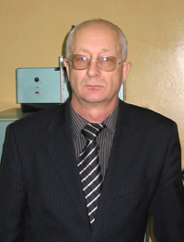

Sergey F. Timofeev
(b. 3/10/1951, Michael Lyalichi region of Primorsky Krai of the Russian Federation), agronomist. PhD (1986), Senior Research Fellow (1992), Associate Professor (2009).

He graduated from Penza Institute of Agriculture (1974). From 1975 to 1984 Fellow of the Polesie Agricultural Experiment Station, from 1984 to 1988 Fellow of All-Union Scientific Research Institute of Legumes and Groat Crops, from 1988 to 2006 Research Fellow, Head of Laboratory RNIUP Institute of Radiology, since 2006 Associate Professor, Department of Botany and Plant Physiology UO Gomel State University named after F. Skoryna.

Work in the field of plant breeding, agricultural chemistry, and agricultural radiology. Author and coauthor of the monograph, more than 240 scientific articles. He was awarded the medal.

Major works:
1.Nakoplenie 90Sr field crops in conditions of radioactive contamination of agricultural land. Radiation biology and radioecology. V.42, No. 3, May-June 2002 P.345-351.
2.Vliyanie fertilizers on the accumulation of 90Sr crops. Vestsi Navuka National Academy of Belarus № 2 2003 sulfur biyalagichnyh Navuka, p.74-80
3.Sostoyanie vegetable agroecosystems in the exclusion zone 20 years after the Chernobyl accident. Radiation Biology. Radioecology. 2007 V. 48, № 1. - S. 57 - 75.
4.Radioaktivnoe contamination of medicinal plants south-east of Belarus. Plant resources. - 2008. - No. 4. - T. 44. - S. 85 - 91.
5. Features of mineral nutrition of leguminous crops cultivated in the sod-podzolic sandy soils contaminated with radionuclides. I Zemlyarobstva APB raslin. № 3 (70), 2010.S.43-46.

