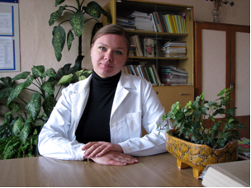
Pyrh Olga
Assistant, She graduated with honors from the Faculty of Biology of the Gomel State University Skorina in 2003, in 2006, completed her graduate studies in the specialty 02.00.02 - "Analytical Chemistry". Since 2006 he works at the Department of Chemistry as an assistant.

Research interests:
Determination of elements in the environment; chemistry of complex compounds
Publications:
1. Korytko OV Synthesis and properties of ion-exchange matrix drug ferrocyanide transition metal / / Sakharov Readings 2006: Environmental Problems of XXI century. Proceedings of the 2nd International Conference. Part II. 18-19 May 2006 - Minsk, 2006. - With. 64-66. 2.
2. Shumilin VA Korytko OV Proleskovsky YA, VA Sobchenko Synthesis, structure, and ion-exchange properties of the matrix of transition metal ferrocyanide / / Sviridov Readings: Collection of articles. Issue 3. - Minsk, 2006. - P.127-131.
3. Shumilin VA Sobchenko VA Korytko OV Ion-exchange properties of drugs KFe [Fe (CN) 6], formed on normal matrices ferrocyanide of copper, zinc, cobalt, and iron (III) / / Proceedings of the GSU them. Skorina. № 1 (40), 2007. P.50-54 4.
4. Sviridenko VG, Zykov EL, Korytko OV Photometric study of iron chelation with citric acid / / Collection of scientific work of teachers. Issue 4. - Nizhyn, 2010. - With. 24-28.
5. Makarenko, T. Study of the composition of surface water. Coolant in Gomel / TV Makarenko, Y. Proleskovsky, EL Zykov, O. Pyrh / / Proceedings of the Gomel State University Skaryna Gomel, 2012. - № 5 (74). - S. 111-116.
6. Sviridenko, VG Especially the organization of independent work of students in analytical chemistry at the Faculty of Biology / VG Sviridenko, EL Zykov, O. Pyrh / / Vestnik Mazyrskaga dzyarzhaunaga pedagagichnaga universiteta imya I.P. Shamyakina, Mozyr, 2012. - № 2 (35). - S. 80-84.

