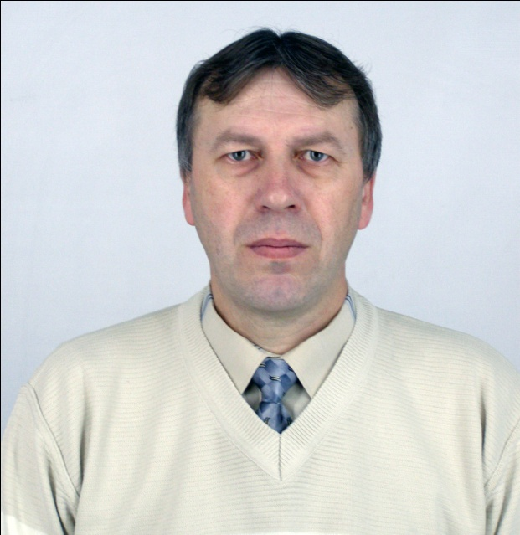

Pyotr V. KOLODIY
Associate professor
Candidate of Agricultural Sciences

Pyotr V. Kolodiy was born on the 17th of December, 1963 in Spasiv (Sokal district, Lvov Region, Ukraine). He is a processing engineer, the Associate professor of Forest Management speciality (2007), the Candidate of Agricultural Sciences (1994).
Mr. Kolodiy graduated from Belarusian State Technological Institute in 1988. Then he had worked his way up from a junior research scientist to Head of Forest Management Department of Forest Institute of the National Academy of Sciences of Belarus in 1988-2007. Since 2007 he is the Associate professor of Forest Management speciality of the Faculty of Biology of our university.
He specializes in the field of forest management, having worked out the standards and methods of thinning operations in mixed and complex saplings.
Mr. Kolodiy is the co-author of 1 monograph, 70 research papers and 1 patented innovation.

Publications:
- Kozhevnikov A.M., Kolodiy P.V. Guidelines for regeneration cuts and reorganization of plantations of various types in the Republic of Belarus / Scientific and technical information in forest management. – Minsk: Belgiproles, 2003. – PP. 21-38.
- Baginskiy V.F., Kolodiy P.V. Conceptual approach to growing of coniferous and oak forest stands mixed with soft-wooded broadleaved species / Izvestiya of Gomel State University. – 2010. - №3 (60). – PP. 132-138.
- Kolodiy P.V., Lazareva M.S., Kolodiy T.A. Technological characteristics of thinning operations in mixed oak saplings / Izvestiya of Gomel State University. – 2011. - №4 (67). – PP. 134-140.

