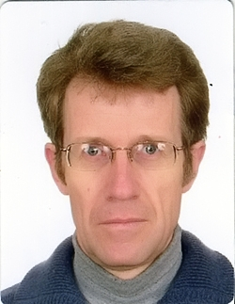

PhD., Alexander Nikolaevich Perevolotsky
(b.08.03.1966, etc. Golynko Kletsk district of the Minsk region). Candidate of Agricultural Sciences (1995).

In 1990-1992. student of the Belarusian Research Institute of Forestry, from 1990 to 1996 - Researcher, Laboratory of Radiology, Institute of Forestry Forest National Academy of Sciences, from 1996 to 2003 Researcher, Laboratory of Radiology, Institute of Forestry Forest National Academy of Sciences.

In 2003 - 2010 Senior Research Associate in the Laboratory of Radioecology forest ecosystems of the Republican Research Unitary Enterprise "Institute of Radiology." Supervisor of the work on "Assessment of radiation exposure anticipated activities of the Belarusian nuclear power plant" (2009). Since 2010 Associate Professor of Human and Animal Physiology Faculty of Biology, GSU ​​them. Skorina.
Work in the field of radiobiology and radiation ecology environmental radiological monitoring of forest ecosystems. Developed a model involving the biological cycle of man-made radionuclides by plants of forest ecosystems and the influence of various factors on the behavior of radionuclides in the environment, risk assessment system of obtaining forest products contaminated with more than acceptable standards,

He participated in the performance of academic research programs in the field of radiation ecology and State programs in the aftermath of the Chernobyl disaster.
He has published over 150 scientific publications, including 3 monographs, 5 textbooks, 40 scientific articles.

Main Publications
1. A. Perevolotsky, AN The distribution of 137Cs and 90Sr in forest biocenosis / AN Perevolotsky. - Gomel RNIUP "Institute of Radiology," 2006. - 255.
2. Perevolotsky, AN Rationale for conducting radiation monitoring system in forest biocenosis at various stages after the accident fallout / AN Perevolotsky, T. Perevolotsky / / Radiation. Biology. Radioecology, 2012. - V. 52, № 3. - S.312-316.
3. Perevolotsky, AN Assessment involving 137Cs in the biological cycle pine biogeocenoses / AN Perevolotsky, T. Perevolotsky / / Radiation. Biology. Radioecology, 2012. - V. 52, № 4. - S.356-362.

