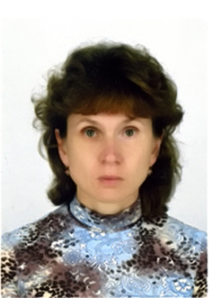
Perevolotskaya Tatiana Vitalievna
Tatiana Vitalievna Perevolotsky (b.04.04.1964, Eremino Gomel district of Gomel region.), A mechanical engineer. Ph.D. in Biological Sciences (2010).
She graduated from the Arkhangelsk Institute of Forestry (1988). In 1988, 1998. Software Engineer of the Belarusian Research Institute of Forestry in 1998 - 2002 Junior Researcher, Laboratory of Forest Ecology Forest Research Institute of NASB. In 2002 -2010, the scientific employee of laboratory of radioecology of forest ecosystems of the Republican Research Unitary Enterprise "Institute of Radiology." Since 2010 senior lecturer in biological sciences department of forestry GSU them. Skorina
Research areas
Work in the field of radiobiology and radiation ecology. Determine the influence of factors of flooding and waterlogging on the migration of 137Cs and 90Sr in forest ecosystems. Developed and implemented in the activities of the Polesie State Radiation and Ecological Reserve system forecasts the state of forest ecosystems at different hydrological regime. Developed and implemented a model of evaluation of radionuclide accumulation timber main forest-forming species and the likelihood of exceeding the permissible standards in geographic information system RadForView.
Artist works on "Assessment of radiation exposure anticipated activities of the Belarusian nuclear power plant" (2009).
He has published over 60 scientific articles.
Main Publications
1. Perevolotsky, T. The effect of flooding on the distribution of 137Cs and 90Sr in the forest biogeocenosis / TV Perevolotsky, I. Bulavik, AN Perevolotsky / / Radiation. Biology. Radioecology, 2009. - V. 49, № 3. - S.291-301.
2. Perevolotsky, T. Assessment involving 137Cs and 90Sr in the biological cycle of Scots pine (Rinus silvestris L.) at different levels of ground water / TV Perevolotsky / / News NASB. A series of biological sciences. -2010. Number 1. - S. 86-90.
3. Perevolotsky, AN Rationale for conducting radiation monitoring system in forest biocenosis at various stages after the accident fallout / AN Perevolotsky, T. Perevolotsky / / Radiation. Biology. Radioecology, 2012. - V. 52, № 3. - S.312-316.

