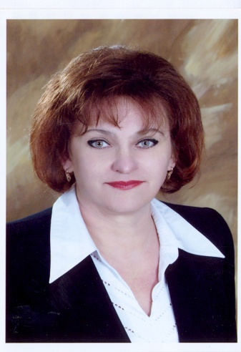

Olga M. Hramchenkova
Ph.D. in Biological Sciences
Associate Professor of Biology in the specialty
Dean of the Faculty of Biology
Gomel State University named after Skorina
________________________________________
EDUCATION
* Biologist. Teacher of Biology and Chemistry, Gomel State University, 1986
* Candidate of Biological Sciences, All-Russian Research Institute of Agricultural Radiology and Agroecology, Obninsk, Kaluga Region, Russia, 1996
* Associate Professor Diploma, Higher Attestation Commission of the Republic of Belarus, 2000
________________________________________
PROFESSIONAL EXPERIENCE
The main positions:
The chief point monitoring, Chernihiv Oblast design and research station chemicalization agriculture, Chernigov, Ukraine, 1986 - 1989
Head of the Laboratory of Radiology, Gomel regional planning and surveying station chemicalization agriculture, Gomel, Belarus, 1989 - 1991
Researcher, Laboratory of Radiochemistry, Research Institute of Radiation Medicine and Endocrinology, Gomel Branch, 1991 - 1997
Head of the Department of Botany and Plant Physiology, Biological Faculty, Gomel State University named after Skorina, 1997 - 2004
Dean of the Faculty of Biology, Gomel State University named after Skorina, 2004
INTERNSHIP:
Intern, Kiev State University. TG Shevchenko Institute of Nuclear Research, USSR Academy of Sciences, Ukraine, 1988
Intern, The Scientific Research Institute of Soil Science and Agricultural Chemistry, 1990
MEMBERSHIP IN SCIENTIFIC COMMUNITY:
Member of the Belarusian Botanical Society
AREA OF RESEARCH
Radioecology, phytoindication, Ecology of soil algae, lichens, mosses
Honours and awards:
Acknowledgement of the Higher Attestation Commission of the Republic of Belarus "for active work on the preparation and certification of highly qualified scientific personnel," 2009
MAIN PUBLICATIONS:
Books
Foliose and fruticose lichens of the city: the determinant of the atlas: a manual for students of biology majors high schools [and others] / AG Tsurikov, O. Hramchenkova, M-Education of the Republic of Belarus, Gomel State. Univ. them. Skorina - Gomel: GSU them. Skorina, 2008. - 123 p.
Articles in journals
AG Tsurikov, O. Hramchenkova. Effect of pH on the incidence of tree bark lichens (on Gomel example). News of systematics of lower plants. T. 43: Sat. articles. - St., M.: Association of Scientific Publications KMK, 2009. - S. 261 - 275.
Tsurykau A., Khramchankova V.: Lichens from Gomel region: a provisional checklist. – Botanica Lithuanica., 2011, 17(4): 157–163.

