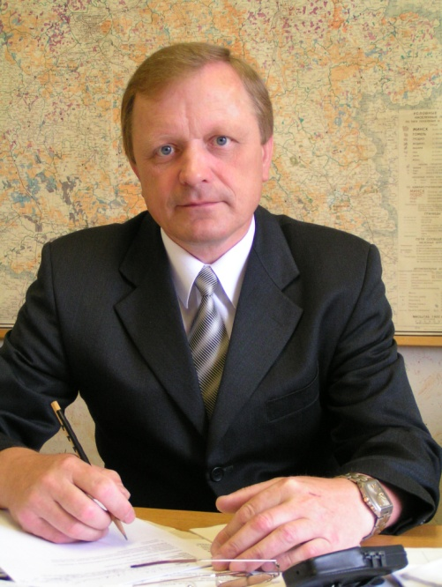
Nikolai V. Mitin
Ph.D. in Biological Sciences, Associate Professor in the specialty "Forestry"
Nikolai Mitin (b. 6/5/1955, p. Small Polpino Bryansk district of the Bryansk region.), A forestry engineer, assistant professor of forest sciences (2007), Ph.D. (2001), Associate Professor (2010).
He graduated from the Bryansk Institute of Technology (1977). The master timber, woodworking master, assistant forester, forester in the Bryansk Zhurinichskom lesokombinat Department of Forestry (1977-1983), engineer, safety and protection of forests experienced forestry BelNIILH Lenin (1983-1987), the instructor of the district committee CP B, Party secretary of the liberated farm named after Lenin Gomel Gomel region (1983-1989), senior researcher, PhD student, junior researcher, researcher, senior researcher, head of the radiation environment of the forest BelNIILH (1989-2007), since 2007 - associate professor of forest biological sciences department of the Gomel State University them. F Skorina.
Research areas
Work in the field of radiation ecology of forests, forestry. Developed methods for reducing the intake of radionuclides in the components of forest plant communities in the contaminated areas.
Co-author of three books, over 100 scientific articles, 9 of inventions.
Main Publications
1 Forest and Chernobyl. Forest ecosystems after the Chernobyl accident 1986-1994 gg. Ed. Acad. NSA V.A.Ipateva. MH.,-C. 177-204. In 1994.
2 Ipatyev V., Bulko N., Mitin N., Dvornik A., Zhuchenko T., Reutsky V. Journal of Envirommental Radioactivity. № 42 (1999) 9-38 (30-33) - 1998.
3 Forest. People. Chernobyl. Forest ecosystems after the Chernobyl accident: the state, the forecast, the reaction of the population, road rehabilitation. Under the general editorship. Academician V.A. Ipateva. Gomel. - S. 291-360. In 1999.

