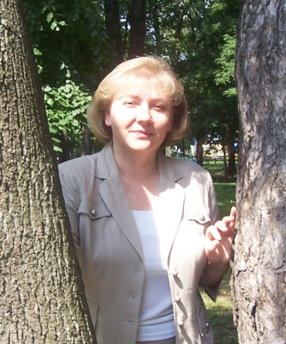

Marina S. Lazareva

Qualifications
Candidate of Agricultural Sciences, Associate Professor in the specialty "Forestry"
Marina S. Lazarev (born 05/09/1961, Lomonosov, Leningrad region)., A forestry engineer. Head of the department of forest sciences (2006), Candidate of Agricultural Sciences (1993), Associate Professor (2011).
She graduated from the Faculty of Forestry Bryansk Institute of Technology (1983). Since 1988, student BelNIILHa (now the National Academy of Sciences Institute of Forest, B), with 1991 engineering laboratory of Forestry, 1992 Junior Researcher, Laboratory of Problems of Forestry and forest management, since 1994 Senior Research Fellow, Department of Forest Science, since 2005 assistant professor of forest biological disciplines Faculty of EE "GSU them. Skorina ", from 2006 Head of the Department.

Research areas
Work in the field of forestry and forestry. The models of growth and formation of mixed oak stands with different variants of mixed breeds, including saplings, the zonal-typological basis. Developed regulations on the formation of mixed oak stands.
The author 67 scientific papers, co-author of three regulatory documents for the Ministry of Forestry of Belarus.
Main Publications:
1 Features of distribution and typological structure of oak plantations of Belarus in the context of forest growth areas / / Proceedings of the Baltic State Technical University. Series I. Forest. s of, Vol. XVII. - Minsk State Technological University, 2009.
2 Climate deterministic dynamics of the typological structure of the pine forests of Belarus in the practice of forest management / / Forest Inventory and forest management. - № 1 (39). Krasnoyarsk. - 2008
3 Patterns of growth and the formation of softwood, oak plantations of Belarus / / Proceedings of the National Academy of Sciences Institute of Forestry. No. 71. - Gomel, IL National Academy of Sciences B, 2011.

