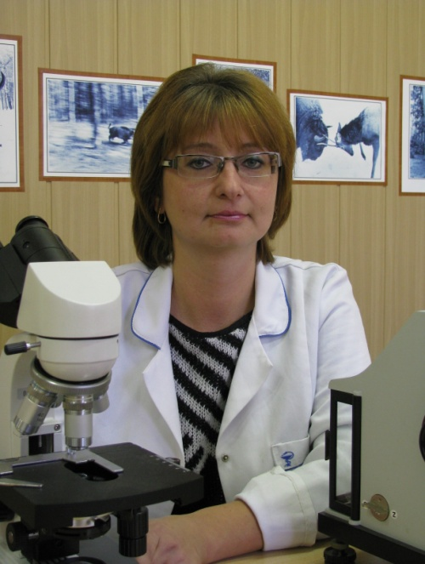
Maltsev Natalia V. (r.12.07.1975, Gomel.), Teacher of biology and chemistry.

She graduated from the Gomel State University. Skorina (2004). In 2005 - 2007. laboratory assistant forest biological sciences faculty GSU them. Skorina since 2007 Assistant Professor of forest biological sciences faculty GSU them. Skorina.
Work in the field lesoobrazovatelnyh processes in oak and forest protection.

Executive job of the State scientific and technical program "Management of forests and sustainable forest management," "Develop programs growing softwood-oak plantations" (2008-2010), the GTIN "Forests of Belarus - sustainability, productivity, efficient use" "Develop and implement standards and technology of formation of broad logging of forests in intermediate derivatives leaved and hornbeam oak plantations and reproduction method of reconstruction trees "(2011-2014).

Author of more than five articles.

Major works:
1. Lazarev, ms analysis and dissemination of state-oak softwood plantations in Belarus in the context of forest growth areas / MS Lazarev, V. Efimenko, LK Klimovich, NV Maltsev / / Problems of silviculture: Sat. scientific. NAS works IL - Gomel: Forest Institute of National Academy of Sciences, 2009. - Vyp.69. - S. 68-81.
2. Lazarev, MS Of growth and the formation of softwood-oak plantations Belarus / MS Lazarev, V. Efimenko, LK Klimovich, NV Mitin, NV Maltsev / / Problems of Forestry and Forestry. Collection of scientific works of the Forest Institute of the NAS of Belarus. No. 71. - Gomel, IL NAS B, 2011. - P.101-108.
3. Fall, AE Pheromone regulation of female fertility gypsy moth (LYMANTRIA DISPAR L.) / AE Fall, NS Blinov. EN Usanova, NV Maltsev / / Proceedings of the Gomel State University Skorina, 2011. - № 4 (67) - Gomel: GSU them. Skorina. - P.167-173.

