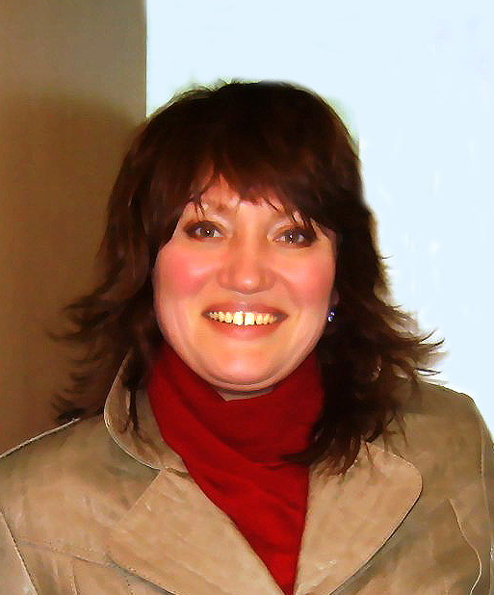
Kurachenko Irina V.
Irina V. Kurachenko (r.02.12.1965, Gomel), biologist, teacher of biology and chemistry.
She graduated from the Gomel State University (1992). Since 1994 he has been working in the Gomel State University, since 1997 Assistant Professor of Zoology and Conservation Biology Faculty GSU them. Skorina, since 2011 - a senior lecturer. Postgraduate (extramural) Gomel State University. F.Skorina from 1996 to 2000., Specialty - Zoology. Topic: "Ecological and population characteristics of commensal parasite of birds and their nests in ecosystems with varying degrees of human impact."
Work in the field of parasitology, ecology and environmental management. Studies the parasite of domestic and synanthropic birds in order to improve animal health and anti-epizootic measures. Participated in the implementation of scientific themes: GB-97-05-F7, GB-96-23-F1 "Study of ecosystems in a low level of contamination and the use of integrated crop protection for environmentally friendly products" (executive in charge), HD02-07 "" (executive in charge); GBTSM 04 - 14 "The study of domestic and commensal parasite of birds" (Grant-2004 Ministry of Higher Education, the head of oil-water); GBTSM 20-17 "Study of ecosystems in a low level of radioactive contamination of the South-East of the country"; GBTSM - 01-63F "Evaluation of long-term effects of the Chernobyl accident on the epizootic situation and physiological status of wild game animals"; GBTSM-01-64F "Assessment of the current dynamics of biodiversity of fauna Belarus Polesie depending on environmental factors." Currently involved in the subject GB 06-15 "The structure and function zoocenoses terrestrial and aquatic ecosystems of Belarus Polesie" GB 11-27 "Evaluation of natural and urban ecosystems of the south-east of Belarus" for 2011-2015, 11 GBTSM -32 "Development of molecular genetic technologies for the diagnosis of Opisthorchosis and other opistorhid in the final and intermediate hosts."
Author of more than 70 scientific and educational works.
Major works:
1. Kurachenko, IV Monitoring the status of populations of parasitic arthropods synanthropic birds nest in man-made landscapes Gomel Environmental issues White-Russian Polissya / I.V.Kurachenko / Sat. scientific. works. - Gomel, 2001. - P.91-99.
2. Kurachenko, IV Structure microbiocenoses synanthropic birds nests major anthropogenic landscape Belarus Polesie / I.V.Kurachenko / / Proceedings of the GSU them. F.Skoriny. Gomel: GSU, 2001. - № 1 (4) - "Biology"., P.18-25.
3. Kurachenko, IV Ecological complexes of arthropods (Arthropoda) jacks rock pigeon Columba livia GM (Aves: Columbiformes) Gomel / I.V.Kurachenko / / Proceedings of the Entomological Society of Kharkov. - Kharkov, 2000. - Volume 8, Issue 2. - S. 80-82.
4. Kurachenko, IV Rating epizootic significance parasite of poultry from his household (for example farms Rechitsa district) / I.V.Kurachenko / / Journal of publications "Actual problems of the humanities and natural sciences." - Moscow, 2011. - № 1 (24). - P.22-27.

