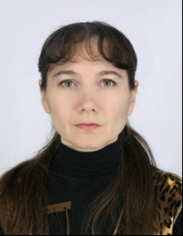
Kolodiy Tatiana A. (1965, Gomel), engineer technician, assistant chair of forestry sciences (2006).
Graduated from the Belarusian Institute of Technology (1989). Junior Research sotrudnikInstituta forest NAS (1996-2006), since 2006 - assistant of forest biological sciences department of the Gomel State University. F Skaryna.
Co-author of 1 book, 30 publications.
His main works
Esimchik LD Ermonina IV, decks T.A.Intensivnost forest in the contaminated forest land / Problems silviculture: a collection of scientific works of the Forest Institute of NASB. No. 53. - Gomel, IL National Academy of Sciences, 2001. - S. 429-431.
Kolodiy TA Model of change quantities of mushrooms in the forests of Belarus / Problems silviculture in contaminated lands: a collection of scientific works of the Forest Institute of NASB. No. 60. - Gomel, IL National Academy of Sciences, 2004. - S. 414-416.
Kolodiy PV, M. Lazarev, a deck of TA Technological features of thinning in young stands of mixed oak / News GSU them. Skorina. - № 4 (67). - 2011. - S. 134-140.

