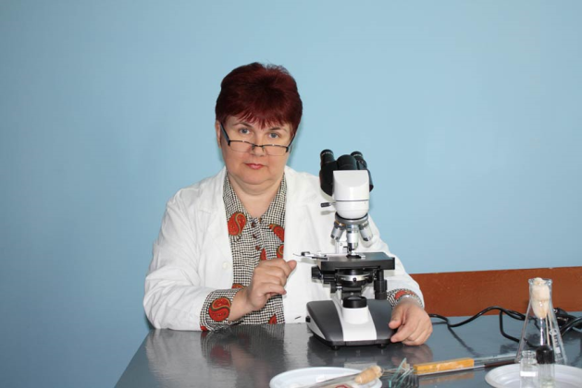
Associate Professor Irina Ilyinichna Kontsevaya

Irina Ilyinichna Kontsevaya (b. 7/12/1962, d Naliboki Stolbtsy district, Minsk region), A geneticist. Ph.D. in Biological Sciences (1990).
Qualifications
She graduated from the Belarusian State University (1984). She graduated from the graduate school of the Institute of Ecological Genetics, National Academy of Sciences of Moldova (1987). Since 1987, specialist of the Institute of Ecological Genetics, since 1991 Senior Research Fellow Department of Biotechnology BSKHA (Gorki), a 1993 Senior Fellow of the Institute of Forest National Academy of Sciences of Belarus (Gomel), since 2008 Associate Professor, Department of Botany and Plant Physiology GSU them. F. Skoryna.
Research areas
Work in the field of gamete plant breeding, cell and tissue culture plants. Established features of pollen selection in breeding tomato at high stress. Clonal micropropagation technology has developed the Karelian birch, optimized methods of prolonged tissue culture of various species of birch.
He has published over 100 scientific publications.
Main Publications
1 A. Effect of selective elimination of pollen on the frequency of recombination in tomato (with Kravchenko AN) / / Proceedings of the Academy of CCPM. - 1991, № 3.
2 Two. Embryo cloudberry (Rubus chamaemorus L.) (in collaboration with Yatsyna AA Yagodkina MV / / Reports of the National Academy of Sciences. - 1998. - V. 42, № 2.
3 Three. Cytogenetic effects of chronic exposure to spruce populations (with Kovalevich AI, Sidor A. / / Problems of Forest and Forestry: Sb.n.tr. - Gomel, 2008. - Vol. 68.
4 Long-term storage microplants birch in tissue culture / / Forestry. - 2009, № 5.
Five. The use of antibiotics in tissue culture Birch / / II End / / Forestry. - 2011. - № 1.

