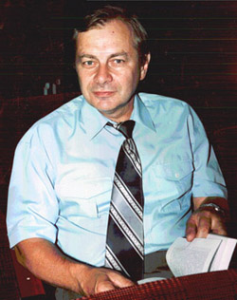
Professor Alexander Mihaylovich Dvornik
Qualifications
Alexander M. Dvornik (b.18.06.1950, Gomel), physicist, biologist, Ph.D. in Mathematics (1988), Doctor of Biological Sciences (1998), Professor (2004).
He graduated from the Physics Department of the Gomel State University (1972).
Since 1975 Research Fellow, Joint Institute for Nuclear Research, Dubna, Moscow region, since 1983 Assistant Professor of Theoretical Physics, 1989 - Assistant Professor. Since 1991. at 2003 Head of the Laboratory of the Forest Institute of NAS of Belarus, since 2003 Professor of Physiology, human and animal EE "Gomel State University named after F.Skorina."
Research areas
Work in the field of radioecology of natural ecosystems, modeling of radionuclide migration. Created a comprehensive system of radiological assessment of forest ecosystems after nuclear accidents, which allows quickly to evaluate and predict the development of radiation environment,
He has published over 130 scientific papers, including two monographs. It has 4 inventor's certificates.
Main Publications
1 Forest. People. Chernobyl. Forest ecosystems after the Chernobyl accident: the state, the forecast, the reaction of the population, road rehabilitation / Ipatyev VA, Baginsky VF, Bulavik I., Dvornik AM Volchkov VE, Goncharenko GG edited by VA Ipatyev - Gomel: Forest Research Institute, Academy of Sciences of Belarus, 1999. - 454s.
2 V. Ipatyev, I. Bulavik, V. Baginsky, G. Goncharenko A. Dvornik Forest and Chernobyl. Forest ecosystems after the Chernobyl nuclear power plant accident. 1986-1994. / / Journal of Environment Radioactivity 42 (1999) 9-38.
3 Dvornik AM, AA Janitor The distribution of 137Cs and 133Ss in forest ecosystems, and modeling of the behavior of the radionuclide / / Problems of Forest and Forestry: a collection of scientific papers IL National Academy of Sciences of Belarus, Gomel, 2011. - Vol. 71. - S. 415-423.

