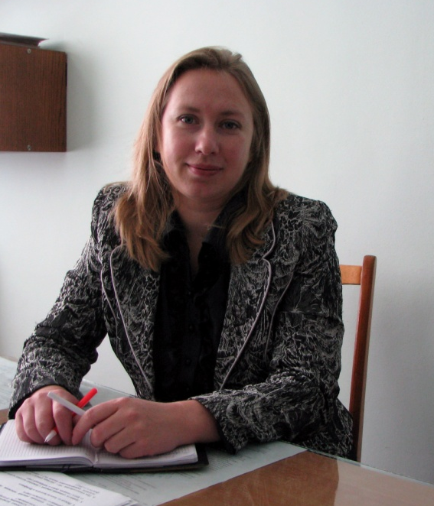

Natalia Ivanovna Drozdova
Qualifications
Drozdov, Natalia (b. 7/30/1973, Gomel), Ph.D. (2003), Associate Professor (2005). Graduated from Gomel State University (1995), postgraduate studies in vivo "Gomel State University" specialty "Analytical Chemistry" (2000), 1995 - Assistant Professor, since 2004 - Associate Professor, since 2009 - head. Department of Chemistry. Head. Department of Chemistry, UO "Gomel State University named. Skaryna "
Contact Information: Gomel 246019, ul. Soviet, 108, Rm. 4.8, Tel.: 8 (0232) 60-14-03,
E-mail: drozdova@gsu.by
Research areas:
Chemistry of coordination compounds.
Voltammetric trace element analysis of natural objects.
Environmental monitoring of the environment. Enzymatic indication of soil contamination.
Doctoral studies at the Chemistry Department of the Jagiellonian University, Krakow, Poland, 2003.
Winner of the contest for young scientists the Gomel Regional Executive Committee (2004).
He has published over 50 scientific articles, co-author of the monograph.
Main Publications
1. Hydroecological the rivers Dnieper basin (within the Gomel region): monograph / IF Rassashko (scientific ed.) [And others] - Gomel: UUE bv / Skaryna, 2008. - 124.
2. Drozdov, N. The use of potentiometric titration for the determination of inorganic complexes of cadmium in solutions / N. Drozdov, VG Sviridenko, AV Hadanovich / / Proceedings of the Gomel State University. Skaryna. Biology. - 2008. - № 5 (50). Part 2 - S. 141-146.
3. Drozdov, N. Effect of high doses of cadmium and lead nitrate on the enzymatic activity of soil / N. Drozdov, VG Sviridenko, AV Hadanovich / / "Youth in science - 2007", Anal. to the journal. "Vestsi natsyyanalnay akademii Navuka Belarus" at 4 pm, Minsk. "Belarusian Science", 2008, Part 3. S. 396-399.
4. Drozdov, N. Investigation of the enzymatic activity of sod-podzolic soil / N. Drozdov, VG Sviridenko, AV Hadanovich, O. Panfilenko / / Proceedings of the Gomel State University named after Skarina, Gomel, 2010. - № 3 (60) - S. 83 - 88.
5. Drozdov, N. Potentiometric study of the processes in solutions гидроксокомплесообразования Mn2 + - Cu2 + (Cd2 +) - NO3--H2O / N. Drozdov, VG Sviridenko, AV Hadanovich / / Catalysis and Petrochemistry, Kiev, 2010. - № 18 - P.22-25
6. Drozdov, NI Effect of heavy metals in soils of industrial areas of Gomel / N. Drozdov, T. Miller, V. Sviridenko, AV Hadanovich / / Proceedings of the Gomel State University named after Skorina, Gomel, 2011. - № 4 (67) Science - S. 114 - 119.

