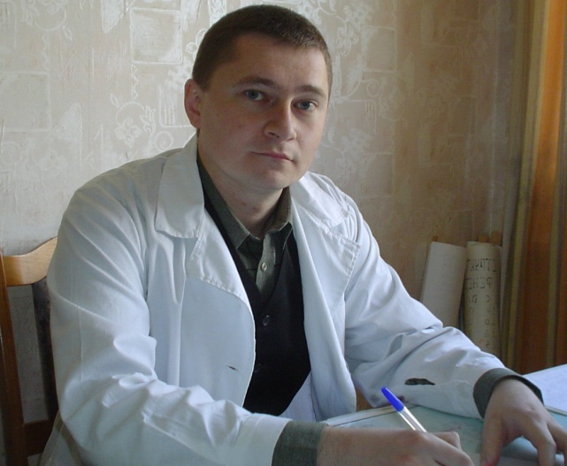
Dmitry V. Potapov (r.04.03.1976, Gomel, Belarus), Assistant Professor of Zoology and Conservation Biology Faculty.
He graduated from the Gomel State University Skarina (1998). In 1998-2000. Assistant Professor of Ecology and basic medical knowledge Mozyr Pedagogical Institute. NK Krupskaya, since 2000 Assistant Professor of Zoology and Conservation Biology Faculty GSU them. Skorina.
Work in the field of ecology and zoology, vertebrate animals. Engaged in the study of population structure and species diversity of vertebrate communities in South-East of the country (species and population structure of the organization of communities of fish, amphibians, reptiles and mikromammaly in different habitats of terrestrial and aquatic ecosystems).
He has authored or co-authored 37 scientific publications, 12 of which were published in the list of WAC Belarus.
Has scientific, methodological and educational publications, including 4 laboratory exercises 2 practical guide, one guide for practical training and one a training complex.
Major works:
Educational publications:
1. Rassashko, IF Fundamentals of Ecology: Teaching method. complex for stud. nebiolog. specials. / IF Rassashko, DV Potapov, GG Goncharenko, VN Veremeev, AV Gulak, A. Crook, IV Kurachenko, Min. arr. RB, EE "GSU F. Skaryna." - Gomel, 2005. - 220.
2. Tsvirko, LS Invertebrate Zoology. Arthropods: Workshop / comp.: LS Tsvirko, DV Potapov, EA Tsvirko. - Mozyr: UO MGPU them. IP Shamyakin, 2008. - 58s.
3. Bakharev, VA Vertebrate Zoology: laboratory. workshop / avt.-comp.: VA Bakharev, DV Potapov. - Mozyr: UO MGPU name IP Shamyakin, 2009. - Laboratory. work № 1-11. Golovohordovye; Cyclostomes, cartilage, bony fish, amphibians. - 101 p.
4. Galinovskii, NG Ecology of the fundamentals of meteorology: a practical guide for students of specialty 1-75 01 01 "Forestry" / NG Galinovskii, D. Potapov, G. Goncharenko, M-Education of the Republic of Belarus, Gomel State. Univ. Skorina. - Gomel: GSU them. Skorina, 2009. - 108 p.
5. Potapov, DV Vertebrate Zoology. Lower chordates, cyclostomes, fishes, amphibians: the laboratory. Workshop for students majoring 1 - 31 01 01 - 02 "Biology (scientific-pedagogical activity)" / DV Potapov [etc.], M-Education of Resp. Belarus, Gomel. State. Univ. Skorina. - Gomel: GGTU them. PO Dry, 2010. - 138 p.
6. Goncharenko, GG Fauna of Belarus: Belarus fisheries / Scient. headed-in / / GG Goncharenko, D. Potapov. - Gomel: GSU them. Skorina, 2012. - 48 p.
Scientific publications:
1. Galinovskii, NG The species composition of rodents living in the Gomel region, not the contaminated / NG Galinovskii, DV Potapov / / Proceedings of the Gomel State University F.Skorina / Scientific and industrial and practical magazine, № 3 (54). - Gomel, 2009. - S. 134-139.
2. Potapov, DV The species composition of rodents in recreational forests in summer / DV Potapov / / Natural Resources of the National Park "Pripyat" and other protected areas in Belarus: the study, conservation, sustainable use: Proceedings of the National Park "Pripyat." - Moscow: Publishing house "Belarusian Printing House", 2009. - S. 330-332.
3. Potapov, DV Species composition and diversity of rodents in recreational forests in the Gomel region / DV Potapov / / Problems of Forestry and Forestry: Proceedings of the National Academy of Sciences IL. Issue 71. - Gomel, IL NAS, 2011. - S. 423-432.
4. Potapov, DV The specific structure of fish communities of the river and its tributaries Sog / DV Potapov, GG Goncharenko / / Proceedings of the Gomel State University F.Skorina / Scientific and industrial and practical magazine, № 4 (67). - Gomel, 2011. - S. 200-206.
5. Goncharenko, GG Taxonomic keys families and species of native fish and fish-ponds of Belarus / GG Goncharenko, D. Potapov / / Proceedings of the Gomel State University F.Skorina / Scientific and industrial and practical magazine, № 5 (74). Natural sciences. - Gomel, 2012. - S. 39-47.

