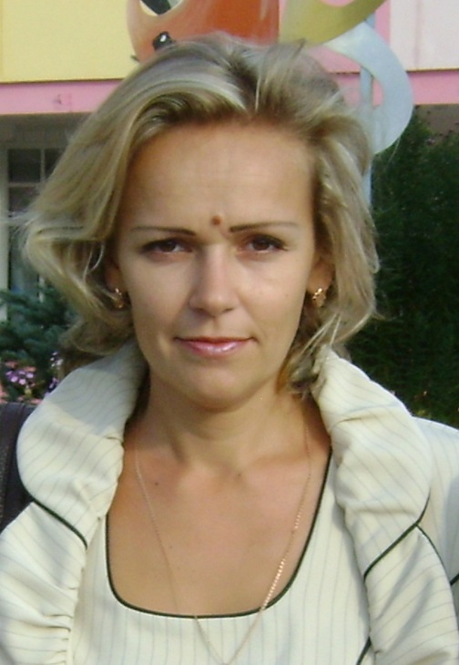
Azyavchikova Tatiana
Tatyana Azyavchikova (b. 07/10/1975, Gomel), biologist, teacher of biology and chemistry.
She graduated from the Gomel State University Skarina (1997), specialization - Chemistry. Postgraduate (full-time education) of the Gomel State University Skarina (1997-2003), a specialty - 03.00.05. Theme: "Population-genetic resources of silver fir in the Eastern European region." Since 2003, Assistant Professor of Zoology and Conservation.
Work in invertebrate zoology, ecology and conservation, genetics. Engaged in the research of the genetic structure of the rural and urban population of south-east Belarus genes controlling the ABO blood group. Participated in the implementation of scientific themes: GBTSM - 10.3 "Parameter estimation of genetic diversity and genetic structure of white fir in Eastern Europe", HBCD - 2.9 "Analysis of the status and management of genetic resources of forest tree softwood Belarus and Siberia", 06 GB - 15 "Structure and function zoocenoses terrestrial and aquatic ecosystems of Belarus Polesie."
Author of more than 20 scientific and educational works.
Major works:
1.Azyavchikova, TV Features of the genetic structure of urban residents Polesie on genes controlling blood group ABO / TV Azyavchikova / / Proceedings of the Gomel State University. Skorina. - 2008. - № 5 (50). - Part 2. - S. 161-167.
2.Azyavchikova, TV Comparative analysis of the genetic structure of urban and rural population of the Gomel area for genes controlling blood group AB0 / TV Azyavchikova / / Proceedings of the Gomel State University F.Skorina / Scientific and industrial and practical magazine, № 5 (56). - Gomel, 2009. - S. 148-152.
3.Azyavchikova, TV Genetic structure of rural and urban south-east Belarus genes controlling blood group ABO / TV Azyavchikova / / Bulletin of the Nizhny Novgorod University NI Lobachevsky. - № 2 (2). - Nizhny Novgorod, 2010. - S. 365-368.
4.Azyavchikova, TV Phenotypic structure of the Colorado potato beetle populations southeastern Belarus / TV Azyavchikova, NS Zdor / / Young Scientist. - Chita, 2012, № 11. - P.120-123.

