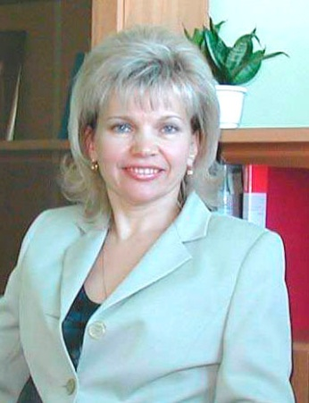
Tamara Arastovich
Associate professor Tamara Arastovich, Сandidate of Agricultural Sciences, was born on the 17th of October,1960 in Bykhov of the Mogilyovregion. Having graduated from Gomel State University in 1983, she had worked at the RSRUE «The Institute of Radiology»,since 2002, the Chief of Department of Radiology of the Gomel Regional Station of Agriculture. Since 2005 she was at the head of Laboratory of Radioecology of Peat Soils, since 2009 – of Laboratory of the Mass Analysis. Since 2012 she is the Associate professor of the Department of Human and Animal Physiology of the Gomel State University.

Sphere of scientific interests: radioecology, agrochemistry, physiology, immunology. She is author more than 50 publications.

Publications:

1.Bogdevich I.M., Podoljak A.G., Arastovich T.V. Increase fertility soils – the basic way to decrease radioactive contamination of forages//Agriculture and protection of plants. —2003.№6. — PP. 14-16.
2.Arastovich T.V. Influence of properties of soils on process of vertical migration of radionuclides.//News of NathionalAcademies of Sciences of Belarus. Series Agrarian Sciences. — 2004. №2 —PP. 62-65.
3.Bogdevich I.M., Podoljak A.G., Arastovich T.V.Radical improvement meadows on territories of radioactive contamination.//Belarus agriculture. — 2004,2 (22). PP. 15-16.

4.Bogdevich I.M., Podoljak A.G., ArastovichТ.В, ZhdanovichV.P. Dependence of accumulation ¹³⁷Cs and ⁹⁰Sr in grasses forages from degree fertility soils//Radiating biology. Radioecology. — 2005, т.45, №2, PP. 241-247.
5.Arastovich T.V., Suzkoo.v. Features of use of peat soilssoils at radioactive contamination//the Bulletin of the Russian army medical college /Part 1. № 3 (23), 2008. – PP. 210-211.

