Information Systems

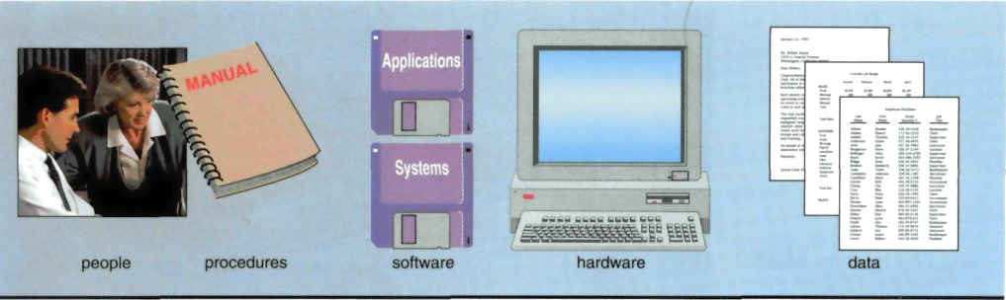

Microcomputer – микрокомпьютер; equipment – оборудование; to overlook – рассматривать, наблюдать; guidelines – руководство, нормативы; manual – справочник, руководство, учебник; step-by-step – пошаговый; purpose – предназначение, цель; to convert into – преобразовывать в; total wages – полная заработная плата; to develop software – разрабатывать ПО; to capture data – собирать данные; essentials – основы.

When you think of a microcomputer, perhaps you think of just the equipment itself. That is, you think of the monitor or the keyboard. Yet, there is more to it than that. The way to think about a microcomputer is as part of an information system. An information system is a collection of five parts: people, procedures, software, hardware, and data.
People: It is easy to overlook people as one of the five parts of an information system. Yet this is what microcomputers are all about – making people, end users like you, more productive.
Procedures: The rules or guidelines for people to follow when using software, hardware, and data are procedures. These procedures are typically documented in manuals written by computer specialists. Software and hardware manufacturers provide manuals with their products. These manuals are provided in either printed or electronic form.
Software: A program consists of the step-by-step instructions that tell the computer how to do its work. Software is another name for a program or programs. The purpose of software is to convert data (unprocessed facts) into information (processed facts). For example, a payroll program would instruct the computer to take the number of hours you worked in a week (data) and multiply it by your pay rate (data) to determine how much you are paid for the week (information).
Hardware: The equipment that processes the data to create information is called hardware. It includes the keyboard, mouse, monitor, system unit (the computer itself), and other devices. Hardware is controlled by software.
Data: The raw, unprocessed facts, including text, numbers, images, and sounds, are called data. Processed data yields information. Using the previous example of a payroll program, the data (number of hours worked and pay rate) is processed (multiplied) to yield information (weekly pay).
Almost all of today’s computer systems add an additional part to the information system. This part, called connectivity, is the ability of a computer to be connected to a network. It typically uses the Internet and allows users to greatly expand the capability and usefulness of their information systems.
In large computer systems, there are specialists who write procedures, develop software, and capture data. In microcomputer systems, however, end users often perform these operations. To be a competent end user, you must understand the essentials of information technology (IT), including software, hardware, and data.

Task 1. MULTIPLE CHOICE.
1. Microcomputers are all about making people, end users, … .
a) happier; b) cleverer; c) stronger; d) more productive;
2. Typically, … are documented in manuals written by computer specialists for particular organizations.
a) people; b) procedures; c) software; d) data;
3. Software is another name for a … .
a); data b) program; c) information; d) computer device;
4. After data is processed through the computer, it is usually called … .
a) software; b) end user; c) procedure; d) information;
5. To be a competent end user, you must understand … .
a) that the Earth is round; b) the essentials of software, hardware and data;
c) Chinese speech; d) how a mainframe works.

Task 2. TRUE OR FALSE.
1. An information system has two parts: hardware and software.
2. Procedures are rules or guidelines to follow when using software, hardware and data.
3. The hardware consists of the raw, unprocessed facts.
4. A program is the step-by-step instructions that tell the computer how to do its work.
5. The purpose of software is to convert information into data.

Task 3. FILL IN THE BLANKS.
1. When you think of a … , perhaps you think of just the … itself.
2. Software and hardware manufacturers also provide … with their products.
3. A program is the … … that tell the computer how to do its work.
4. The hardware consists of the … : keyboard, monitor, printer, and other devices.
5. In large computer systems, there are specialists who deal with writing procedures, …, and … .

Task 4. ANSWER THE QUESTIONS.
1. How many parts of an information system do you know?
2. What are procedures?
3. What is the purpose of software?
4. What hardware devices can you name?
5. Can you distinguish data from information?

