***How Will Technology Impact Us?***

**Employment and the Economy:**

Perhaps the most fundamental and direct impact that technology has on the everyday life of most people is economic in nature. The issue of jobs and unemployment is one that strikes a chord of concern in just about every person. While competition between machinery and human labor has long existed in the realm of physical tasks, it has only recently been introduced into the domain of mental work. Much as heavy machinery has eliminated the need for physical exertion on the part of humans, so too does modern technology, in the form of microchips and computers, bring with it the potential to eliminate mental drudgery. Does this mean, however, that humans will no longer have any purpose to serve in the world?

To gain some perspective on the issue, we can take a look at the past. At the beginning of the 20th century in the United States, jobs in factories and agriculture were disappearing at a rapid rate. But with the loss of those jobs came the potential for millions of new jobs and economic development in new industries. Indeed the macroeconomic trend of the past century has been overwhelmingly positive. Jobs have grown 10-fold in the United States (from 12 million in 1870 to 116 million in 1985) and the percentage of people employed has grown from 21 percent to 48 percent. Per-capita gross national product, as well as the average earning power of jobs, has increased 600 percent in constant dollars during the same period. Today, new manufacturing technologies are rapidly reducing the number of production jobs. The advent of new technology is projected to rapidly decrease the demand for clerical workers and other such semiskilled and unskilled workers.

How will the development of more advanced software affect our economy? Is technology bound to provide for economic growth? Is it possible for computers and technology to truly replace humanity?

**Society:**

Computers, which have revolutionized the workplace, are similarly infiltrating society. They have brought about innumerable advances in education and personal communication.

Slowly but surely, computers have begun to infiltrate the classroom. Though not yet optimized for education, the personal computer has much potential in this arena. Wireless networks can allow for the easy sharing of courseware, submissions by students of papers, exams, courseware responses, and other creations. The networking of information can provide students with instant access to vast amounts of information and knowledge.

The realm of communications has likewise seen immense change. We are provided with new ways to communicate with each other, such as email and instant messaging. Documents placed on the internet are sources of information for the rest of the world. Vast databases allow for the easy storage of information. Global positioning satellites allow us to track our exact location and find our way to various destinations.

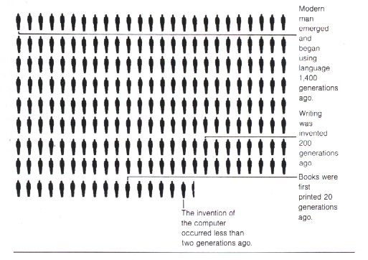

But what social problems will arise with such progress? Will we become increasingly dependent on our computers to the point of social breakdown? As Theodore Kaczynski wrote, "technology is a more powerful social force than the aspiration for freedom, …while technological progress AS A WHOLE continually narrows our sphere of freedom, each new technical advance CONSIDERED BY ITSELF appears to be desirable." Will technology be so ingrained in society as to destroy it and imprison humanity?

**Military:**

The potential applications of technology to warfare are well known. But is this application positive or negative?

One might argue that the military application of science is undoubtedly negative in that it has led to the creation of the atomic bomb and other such weapons of mass destruction. Technology has made the complete destruction of humanity possible. That capacity continues to grow, as more nations develop nuclear technology and the proliferation of nuclear warheads continues.

On the other hand, it is also possible to argue that science has made it possible for the more accurate destruction of enemy targets and, in doing so, has lessened unintended damage to civilian populations. Smart bombs and cruise missiles have lessened the human component of war at least to some degree.

But what will the effect of future technology be? Will it lessen the amount of destruction and death? Or will it be our ultimate undoing?