**Operating Systems**

An **operating system** is a collection of programs that handle many of the technical details related to using a computer. In many ways, an operating system is the most important type of computer program. Without a functioning operating system, your computer would be useless.

Every computer has an operating system and every operating system performs a variety of functions. These ***functions*** can be classified into three groups:

• **Managing resources:** Operating systems coordinate all the computer’s resources including memory, processing, storage, and devices such as printers and monitors. They also monitor system performance, schedule tasks, provide security, and start up the computer.

• **Providing user interface:** Operating systems allow users to interact with application programs and computer hardware through a **user interface.** Many older operating systems used a character-based interface in which users communicated with the operating system through written commands such as “Copy A: assign.doc C:”. Almost all newer operating systems use a **graphical user interface (GUI).** It uses graphical elements such as icons and windows.

• **Running applications:** Operating systems load and run applications such as word processors and spreadsheets. Most operating systems support **multitasking,** or the ability to switch between different applications stored in memory. With multitasking, you could have Word and Excel running at the same time and switch easily between the two applications. The program that you are currently working on is described as running in the **foreground.** The other program or programs are running in the **background.**

Starting or restarting a computer is called **booting** the system. There are two ways to boot a computer: a warm boot and a cold boot. A **warm boot** occurs when the computer is already on and you restart it without turning off the power. Starting a computer that has been turned off is called a **cold boot.**

You typically interact with the operating system through the graphical user interface. Most provide a place, called the **desktop,** that provides access to computer resources. (See Figure 5-2.) Operating systems have several ***features*** in common with application programs, including

• **Icons –** graphic representations for a program, type of file, or function.

• **Pointer –** controlled by a mouse, trackpad, or touchscreen, the pointer changes shape depending upon its current function. For example, when shaped like an arrow, the pointer can be used to select items such as an icon.

• **Windows –** rectangular areas for displaying information and running programs.

• **Menus –** provide a list of options or commands.

• **Tabs –** divide menus into major activity areas.

• **Dialog boxes –** provide information or request input.

• **Help –** provides online assistance for operating system functions and procedures.

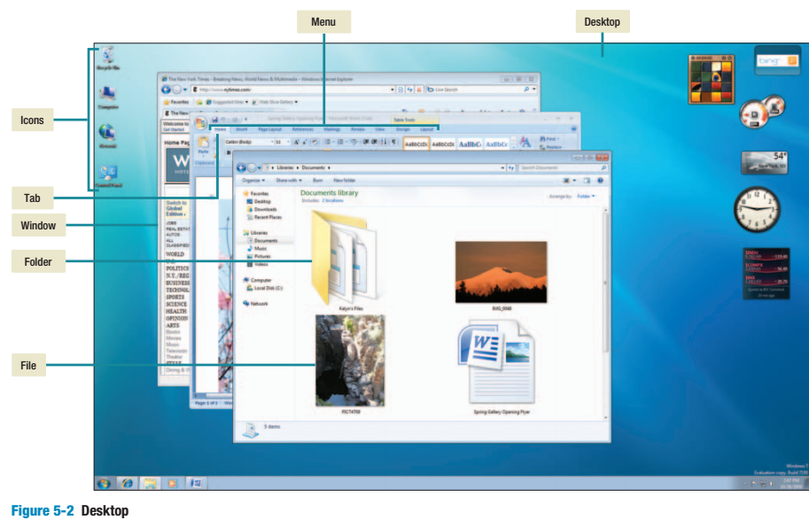

Most operating systems store data and programs in a system of files and folders. Computer files and folders are stored on a storage device such as your hard disk. **Files** are used to store data and programs. Related files are stored within a **folder,** and for organizational purposes, a folder can contain other folders.

While there are hundreds of different operating systems, there are only three basic ***categories***: embedded, network, or stand-alone.

• **Embedded operating systems** are used for handheld devices such as smartphones, cable and satellite television tuner boxes, video game systems, and other small electronics. The entire operating system is stored within or embedded in the device. The operating system programs are permanently stored on ROM, or read-only memory, chips.

• **Network operating systems (NOS)** are used to control and coordinate computers that are networked or linked together. Network operating systems are typically located on one of the connected computers’ hard disks. Called the **network server,** this computer coordinates all communication between the other computers. Popular network operating systems include NetWare, Windows Server, and UNIX.

• **Stand-alone operating systems,** also called **desktop operating systems,** control a single desktop or notebook computer. These operating systems are located on the computer’s hard disk. Often desktop computers and notebooks are part of a network. In these cases, the desktop operating system works with the network’s NOS to share and coordinate resources. In these situations, the desktop operating system is referred to as the *client operating system.*

The operating system is often referred to as the **software environment** or **platform.** Almost all application programs are designed to run with a specific platform. For example, Apple’s iMovie software is designed to run with the Mac OS environment. Many applications, however, have different versions, each designed to operate with a particular platform. For example, one version of Microsoft Office is designed to operate with Windows. Another version is designed to operate with Mac OS.

**CONCEPT CHECK**

1. What is an operating system?

2. Discuss operating system functions and features.

3. Describe each of the three categories of operating systems.