Data

Data is raw, unprocessed facts, including text, numbers, images, and sounds. As we have mentioned earlier, processed data becomes information. When stored electronically in files, data can be used directly as input for the system unit. Four common types of files (see Figure 1-15) are

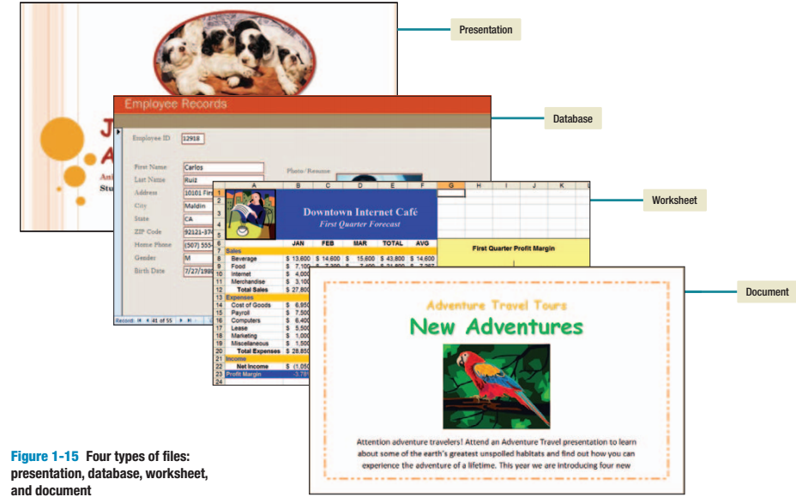

• Document files, created by word processors to save documents such as memos, term papers, and letters.
• Worksheet files, created by electronic spreadsheets to analyze things like budgets and to predict sales.
• Database files, typically created by database management programs to contain highly structured and organized data. For example, an employee database file might contain all the workers’ names, social security numbers, job titles, and other related pieces of information.
• Presentation files, created by presentation graphics programs to save pre sentation materials. For example, a file might contain audience handouts, speaker notes, and electronic slides.

Connectivity, the Wireless Revolution, the Internet, and Cloud Computing

Connectivity is the capability of your microcomputer to share information with other computers. The two most dramatic changes in connectivity in the past five years have been the widespread use of mobile or wireless communication devices and cloud computing. Many experts predict that these wireless applications are just the beginning of the wireless revolution, a revolution that will dramatically affect the way we communicate and use computer technology.
Central to the concept of connectivity is the network. A network is a communications system connecting two or more computers. The largest network in the world is the Internet. It is like a giant highway that connects you to millions of other people and organizations located throughout the world. The Web provides a multimedia interface to the numerous resources available on the Internet. Cloud computing uses the Internet and the Web to shift many computer activities from a user’s computer to computers on the Internet. The wireless revolution and cloud computing promise the potential to dramatically affect the entire computer industry and how you and I will interact with computers. Each will be discussed in detail in the following chapters.

CONCEPT CHECK

1. Define data. Differentiate between data and information.
2. List four common types of files.
3. Define connectivity and the wireless revolution.

