**HIGHER EDUCATION**

**IN ENGLISH-SPEAKING COUNTRIES**

**I How to Choose the Right University**

*1 Vocabulary box.*

to fit interests

academic background

to narrow down the choice

target university

to climb the career ladder

to ace exams

main priority

a more laid-back academic environment

to get homesick easily

to cover tuition fees

to search for financial aid

to obtain a loan

Choosing which university fits your interests and academic background is an important decision that will greatly influence the success of your university study. In the UK alone, there are hundreds of choices and therefore you need to be strategic in making a shortlist of universities and narrowing down your choices into second and first choice. This involves weighing some factors such as your motivation and aspiration, your personality, your location, and your budget.

People attend university for different reasons, so ask yourself what you want from your target university and what you want to do after you graduate. Many people attend top universities because of the prestige without considering their choice of future career. If you have interest in a particular career, you should find universities with a better reputation for your career choice than others. With a degree from a university that is most respected in the profession you want to enter, it will be easy for you to get your dream job and you will be able to climb the career ladder fast.

Your personality types also play an important role in your success as a university student. A scholarly type student usually has self-motivation to work hard in order to ace exams and achieve high grades. This type of person will find comfort in a highly academic environment offered by top world universities such as Oxford or Cambridge. On the contrary, if you are not a type of person who can study for hours and getting top grades is not your main priority, you better go to a university with a more laid-back academic environment so that you will not be stressful all the time and can enjoy your life at university.

Coming home could be a good escape during your hard time at university, so think about the distance between your home and the target university. If you get homesick easily, you should not consider choosing a university outside your hometown or which takes more than a day to travel by land or water. However, if distance is not a problem for you, you might want to consider studying abroad, especially at a university whose reputation is better than the universities in your home country.

Last but not least, calculate your financial ability, which should cover tuition fees and cost of living. Both vary across the country and different universities, so do your homework by doing some research in order to find out which one fits your bills. If you cannot afford to go to the university of your choice, you can search for financial aid in the forms of student loans, grant, or scholarship. Do remember that if you decide to obtain a loan, you have to pay for it after you finish your study.

*2 Reading comprehension questions.*

1) Why do you need to choose the right university?

a) Because it will make you happy.

b) Because it has an impact on your success at university.

c) Because life at university is difficult.

d) Because the right university is difficult to find.

2) Which university should you go to if you already have a career choice?

a) One with the lowest tuition fees.

b) One that offers you a scholarship.

c) One that has the highest prestige.

d) One that has a good reputation in your future profession.

3) What type of student will enjoy a highly academic environment?

a) A student who has self-motivation to work hard.

b) A smart student who does not need to study hard for exams.

c) A student who puts the highest priority on student societies.

d) A student who does not have a part-time job.

4) Where should you study if you are prone to homesickness?

a) Abroad.

b) Outside your hometown.

c) At your local university.

d) At home.

5) What can you do if you do not have enough money to fund your study?

a) Wait for a year to collect money.

b) Find a full-time job.

c) Choose to study online.

d) Find a student loan or scholarship.

*3 Discuss with group-mates what universities could fit your interests and financial abilities.*

*If you could choose any university in the world, where would you go and why?*

**II Higher Education in the United Kingdom**

*1 Vocabulary box.*

to offer higher education

research-oriented

self-governing

to arrange courses

to award the degrees

scientifically biased

admission to the universities

old trial patterns

to extend for years

to keep up with their fellow students

In the United Kingdom, higher education is offered by universities and non-university institutions (colleges, institutes, schools and academies). They provide both research-oriented and higher professional education. There are around 130 universities and university colleges in England, Scotland, Wales and Northern Ireland. British universities are independent autonomous self-governing institutions. The most famous of them are: Cambridge, Oxford, Edinburgh, London, Essex, Aberdeen and many others.

The university is like a federation of colleges. It arranges courses, lectures, exams; and awards the degrees. The universities of Oxford and Cambridge each have over 10000 full-time students. Oxford is older than Cambridge, more philosophical and classical. Cambridge, on the other hand, is more scientifically biased. But in many respects (their prestige and wealth) they look alike. Admission to the universities is based on the old trial patterns.

Degree programmes culminate to a degree (bachelor’s, master’s, or doctor’s degree) and non-degree programmes lead to a vocational qualification such as a certificate or diploma.

University degree courses generally extend for 3 or 4 years though in medicine 5 or 6 years are required. The first degree of Bachelor is awarded on the completion of such a course with satisfactory examination results. Further study or research is required at modern universities for the degree of Master and by all universities for the degree of Doctor. Universities are centres of research and teaching.

University teaching combines lectures, practical classes (in scientific subjects) and small group teaching in either seminars or tutorials.

At Oxford, a ***Tutor*** is a member of staff (professor) who supervises students’ work individually. Each student goes to his tutor’s room for an hour every week to read out an essay which he/she and the tutor then discuss. The tutor can help with general problems (choice of courses, difficulty in keeping up with their fellow students) and practical problems (family matters, finding accommodation). Then there is a ***Dean***, who is in charge of the discipline among 300 students inside the College. Last there are ***Directors of Studies*** and their assistants – ***Supervisors***.

In some unis in the UK the term ***dean*** is used for the head of a ***faculty***, a collection of related academic departments. There are also ***lecturers*** or ***instructors***, ***registrars***, and ***advisors***.

Most adequately qualified British students can obtain awards from public funds in order to attend full-time at a university. The amount of these awards depends on the income of the student and his parents. Grants for postgraduate study are offered annually by the Department of Education and Science, the Research Councils.

*2 Open ended.*

1) What are the post-school institutions of higher education?

2) What are the most famous universities of Great Britain?

3) What is a British university like?

4) How long do University degree courses generally last?

5) What degrees do universities in the UK award?

6) What does a Tutor at Oxford do?

7) What is a tutorial?

8) What does the word “dean” mean?

*3 Speak about higher education in Great Britain in general or give a short presentation on Cambridge and Oxford.*

**III Studying in the UK: the pros and cons**

*1 Watch the video “Studying in the UK: the pros and cons” on YouTube. Before watching make sure you understand the following phrases from the video.*

to think independently

to think critically

a creative thinker

to memorise things

to acquire knowledge

the emphasis

to be valued by employers

to develop skills

to have access to

extracurricular activities

knowledge heavy

to apply for

to be worth smth/doing smth

to be recognized

*2 Translate the sentences.*

1) In the UK universities teach you how to be independent, how to think independently, how to think critically, how to debate, argue, how to be a creative thinker.

2) In a lot of countries universities teach you how to memorise things and you learn how to acquire knowledge rather than create knowledge.

3) In British universities the emphasis is very much on critical thinking.

4) This skill is definitely valued by employers.

5) In the UK students have access to a lot of international research.

6) They provide students with those extracurricular activities that help develop their personality and develop them as people in general.

7) British universities are not so knowledge heavy.

8) If you’re an international student it’s even more expensive but there might be scholarships and grants that you might be able to apply for.

9) You just have to decide whether it’s worth it or not.

10) Some universities in the UK are not necessarily recognized by employers in other countries.

*3 Fill in the following table:*

|  |  |
| --- | --- |
| ***Studying in the UK*** | |
| **Pros** | **Cons** |
| 1  2  3  … | 1  2  3  … |

*4 Compare the systems of higher education in Great Britain and Belarus (See “Supplementary Reading”). What are the differences? What do they have in common?*

**IV The System of Higher Education in the United States**

*1 Vocabulary box.*

counterparts

nationwide assumption

to spring up

substantial

vast majority

to assess

by means of

broad range of subject areas

to pursue

to derive from

to be adopted by

wholesale

The system of higher education in the United States differs from its counterparts in Europe in certain ways.

In the United States, there is a nationwide assumption that students who have completed secondary school should have at least two years of university education. Hence, a great number of “junior colleges” and “community colleges” have sprung up to provide two years of undergraduate study, in contrast to the traditional universities and colleges, where a majority of students complete four years of study for a degree and where substantial numbers go on for one to three years of postgraduate study in a “graduate school.”

Universities that provide four-year study courses are either privately funded foundations or are state or city foundations that depend heavily on the government for financial support. Private universities and colleges depend largely on tuition charges levied on students. The individual state governments fund the nation’s highly developed system of state universities, which ensure the provision of higher education for the vast majority of those willing and academically qualified to receive such education.

In the American system, the four-year, or “bachelor’s,” degree is ordinarily obtained not by passing a “finals” examination but rather by the accumulation of course “credits,” or hours of classroom study. The quality of work done in these courses is assessed by means of a continuous record of marks and grades in a course transcript. The completion of a certain number (and variety) of courses with passing grades leads to the “bachelor’s” degree. The first two years of a student’s studies are generally taken up with prescribed courses in a broad range of subject areas, along with some “elective” courses selected by the student. In the third and fourth years of study, the student specializes in one or perhaps two subject fields. Postgraduate students can pursue either advanced studies or research in one of the many graduate schools, which are usually specialized institutions. At these schools students work toward either a “master’s” degree (which involves one to two years of postgraduate study) or a doctoral degree (which involves two to four years of study and other requirements).

A marked feature of American education that derives from the German model is the de-emphasis on lecture and examination. In both of these countries, students are evaluated according to their performance in individual courses where discussion and written essays figure importantly. The American model of higher learning was adopted wholesale by the Philippines and influenced the educational systems of Japan and Taiwan after World War II.

*2 Describe the US system of education using this chart and the Internet.*

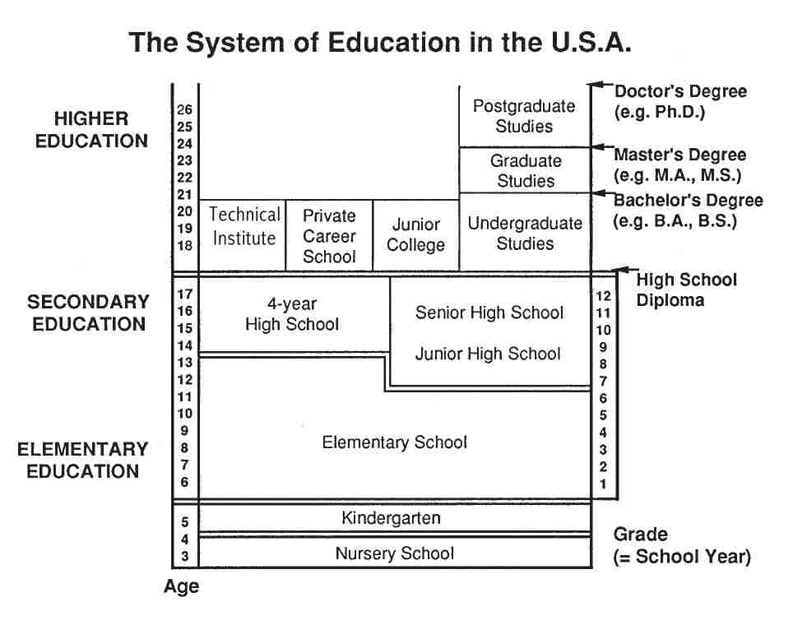

*3 Give a short presentation on the most famous Universities of the USA.*

## V Making Presentations

## 1 Choose one of the topics to make a Power Point presentation:

## 1) British Universities – traditions and modern life.

## 2) Interesting facts about Oxford (Cambridge, Harvard, Stanford).

## 3) Universities and colleges in the USA.

## 4) Higher Education in Canada (Australia, New Zealand).

## 5) Most unusual universities of the world.

## 6) Students’ life in the USA (Great Britain, Canada, Australia, New Zealand).

*2 Keep these tips in mind to create a successful Power Point presentation.*

1) Don’t read your presentation straight from the slides.

Include only main ideas, keywords, and talking points in your slide show text.

2) Follow the 5/5/5 rule.

Keep the text on each slide short and to the point. Some experts suggest using the 5/5/5 rule: no more than five words per line of text, five lines of text per slide, or five text-heavy slides in a row.

3) Don’t forget your audience.

Know your audience, and tailor your presentation to their tastes and expectations.

4) Choose readable colors and fonts.

Your text should be easy to read and pleasant to look at. Large, simple fonts and theme colors are always your best choice.

5) Don’t overload your presentation with animations.

Before including effects in your presentation, ask yourself: Would this moment in the presentation be equally strong without an added effect? Does it unnecessarily delay information? If the answer to either question is yes leave out the effect.

6) Use animations to enhance your presentation.

Don’t take the last tip to mean you should avoid animations and other effects entirely. When used sparingly, subtle effects and animations can add to your presentation. For example, having bullet points appear as you address them can help keep your audience’s attention.