**Communications**

*Computer communications* is the process of sharing data, programs, and information between two or more computers. Numerous applications depend on communication systems including

• **E-mail –** provides a fast, efficient alternative to traditional mail by sending and receiving electronic documents.

• **Instant messaging –** supports direct, “live” electronic communication between two or more friends or buddies.

• **Internet telephone –** provides a very low-cost alternative to long-distance telephone calls using electronic voice and video delivery.

• **Electronic commerce –** buying and selling goods electronically.

Connectivity, the wireless revolution, and communication systems are key concepts and technologies for the 21st century.

**Connectivity** is a concept related to using computer networks to link people and resources. For example, connectivity means that you can connect your microcomputer to other computers and information sources almost anywhere. With this connection, you are linked to the world of larger computers and the Internet. This includes hundreds of thousands of Web servers and their extensive information resources.

**The Wireless Revolution**

The single most dramatic change in connectivity and communications in the past few years has been the widespread use of mobile telephones with wireless Internet connectivity. Students, parents, teachers, businesspeople, and others routinely talk and communicate with these devices. This wireless technology allows individuals to stay connected with one another from almost anywhere at any time.

So what’s the revolution? While wireless technology was originally used primarily for voice communications, today’s cell phones support e-mail, Web access, and a variety of Internet applications. In addition, wireless technology allows a wide variety of nearby devices to communicate with one another without any physical connection. You can share a high-speed printer, share data files, and collaborate on working documents with a nearby co-worker without having your computers connected by cables **–** wireless communication. But is it a revolution? Most experts say yes and that the revolution is just beginning.

**Communication systems** are electronic systems that transmit data from one location to another. Whether wired or wireless, every communication system has four basic elements. (See Figure 9-2.)

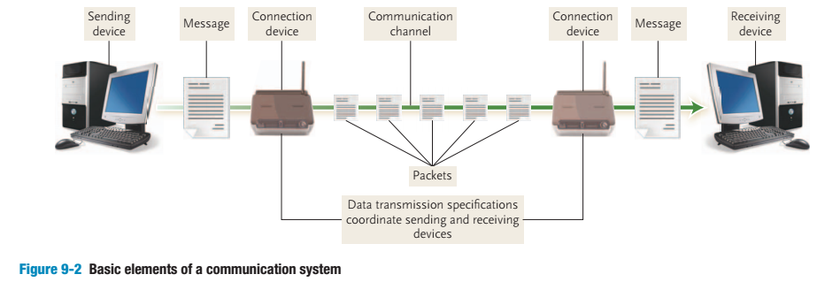

• **Sending and receiving devices.** These are often a computer or specialized communication device. They originate (send) as well as accept (receive) messages in the form of data, information, and/or instructions.

• **Communication channel.** This is the actual connecting or transmission medium that carries the message. This medium can be a physical wire or cable, or it can be wireless.

• **Connection devices.** These devices act as an interface between the sending and receiving devices and the communication channel. They convert outgoing messages into packets that can travel across the communication channel. They also reverse the process for incoming messages.

• **Data transmission specifications.** These are rules and procedures that coordinate the sending and receiving devices by precisely defining how the message will be sent across the communication channel.

For example, if you wanted to send an e-mail to a friend, you could create and send the message using your computer, the *sending device.* Your modem, a *connection device,* would modify and format the message so that it could travel efficiently across *communication channels,* such as telephone lines. The specifics describing how the message is modified, reformatted, and sent would be described in the *data transmission specifications.* After your message traveled across the channel, the receiver’s modem, a *connection device*, would reform it so that it could be displayed on your friend’s computer, the *receiving device.*

**CONCEPT CHECK**

1. Define computer communications and connectivity.

2. What is the wireless revolution?

3. Describe the four elements of every communication system.

**Networks**

A **computer network** is a communication system that connects two or more computers so that they can exchange information and share resources. Networks can be set up in different arrangements to suit users’ needs. (See Figure 9-15 .)

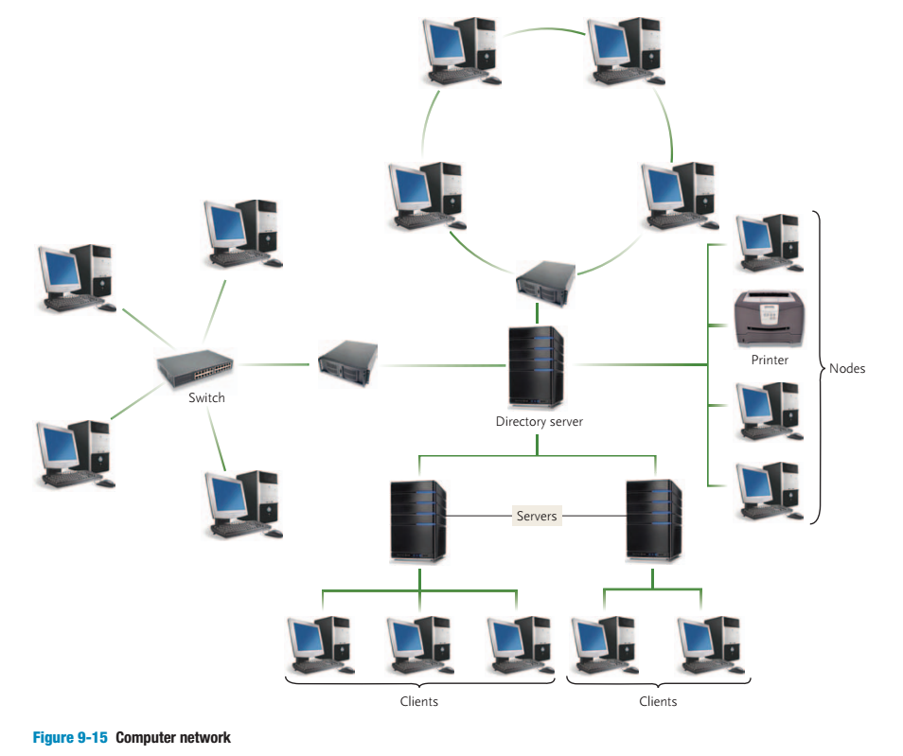

There are a number of specialized *terms* that describe computer networks. These include

• **Node –** any device that is connected to a network. It could be a computer, printer, or data storage device.

• **Client –** a node that requests and uses resources available from other nodes. Typically, a client is a user’s microcomputer.

• **Server –** a node that shares resources with other nodes. Dedicated servers specialize in performing specific tasks. Depending on the specific task, they may be called an application server, communication server, database server, file server, printer server, or Web server.

• **Directory server –** a specialized server that manages resources, such as user accounts, for an entire network.

• **Host –** any computer system that can be accessed over a network.

• **Switch –** central node that coordinates the flow of data by sending messages directly between sender and receiver nodes. A **hub** previously filled this purpose by sending a received message to all connected nodes, rather than just the intended node.

• **Network interface cards (NIC) –** expansion cards located within the system unit that connect the computer to a network. Sometimes referred to as a LAN adapter.

• **Network operating systems (NOS) –** control and coordinate the activities of all computers and other devices on a network. These activities include electronic communication and the sharing of information and resources.

• **Network administrator –** a computer specialist responsible for efficient network operations and implementation of new networks.

A network may consist only of microcomputers, or it may integrate microcomputers or other devices with larger computers. Networks can be controlled by all nodes working together equally or by specialized nodes coordinating and supplying all resources. Networks may be simple or complex, self-contained or dispersed over a large geographical area.

**CONCEPT CHECK**

1. What is a computer network?

2. What are nodes, clients, servers, directory servers, hosts, and switches?

3. What is the function of an NIC and an NOS?

4. What is a network administrator?